WHERE ARE YOU FROM?
WHAT NATIONALITY ARE YOU?
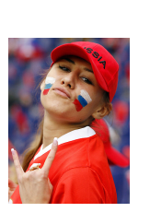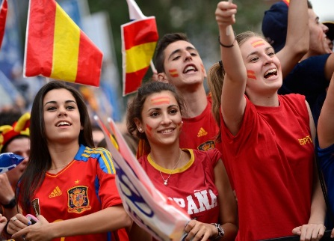
a b c d
_________ ________ __________ ________________

* | COUNTRIES | NATIONALITIES
*  *  *  *  * | I am …  He is…  We are…  You are…  They are… | I am …  She is…  We are…  You are…  They are…
 | from Brazil | Brazilian
 | from Great Britain  (= The U.K. = The United Kingdom) | British
 | from Germany | German
 | from Japan | Japanese
 | from Poland | Polish
 | from Russia | Russian
 | from Spain | Spanish
 | from the U.S.A.  (= the United States of America) | American
 | from Canada | Canadian
 | from France | French
 | from China | Chinese
 | from Chile | Chilean

